O'ZBEKISTON RESPUBLIKASI HARBIY XAVFSIZLIK VA MUDOFAA UNIVERSITETINING
AXBOROT-KOMMUNIKATSIYA TEXNOLOGIYALARI VA HARBIY ALOQA INSTITUTI


Sun’iy intelekt asoslari fanidan

1-TOPSHIRIQ

Guruhi: 4/10-22
Bajardi : Kursant Abduraxmonov.S.A.
Tekshirdi : Kapitan Isakov M.
Toshkent – 2025

1.Shaxmat doskasining x,y kordinatalari berilgan (1-8 oralig’ida yotuvchi butun son). Doskaning chap past burchagi (1,1) qoraligini hisobga olib jumlani rostlikka tekshiring: “berilgan (x,y) maydon oq”
2.n butun son berilgan (n>0). Quyidagi yigindini hisoblovchi programma tuzilsin.S=n²+(n+1)²+(n+2)²+…(2*n)²
3.butun musbat sonni ifodalovchi ikkilik sanoq sistemasidagi son satrda berilgan.bu sonning o’nlik sanoq sistemasidagi qiymatiniozoda saqlovchi satni chiqaruvchi programma tuzilsin
JAVOBLAR:
1.
x = int(input("x ni kiriting : "))
y = int(input("y ni kiriting : "))
if 1 <= x <= 8 and 1 <= y <= 8:
if (x + y) % 2 == 0:
print(f"({x}, {y}) — qora katak.")
else:
print(f"({x}, {y}) — oq katak.")
else:
print("x va y 1 dan 8 gacha butun son bo‘lishi kerak!")
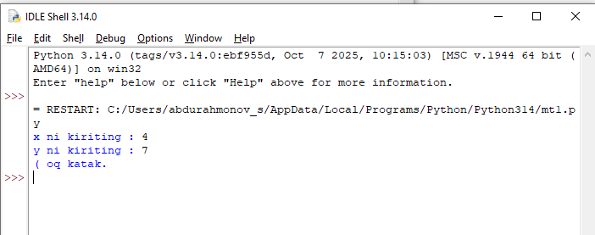
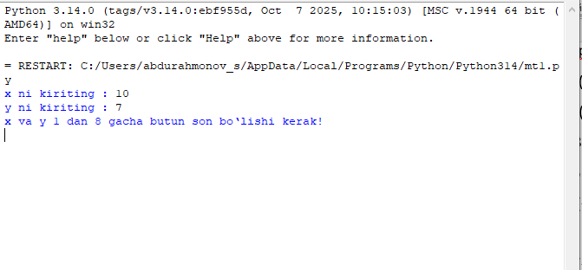
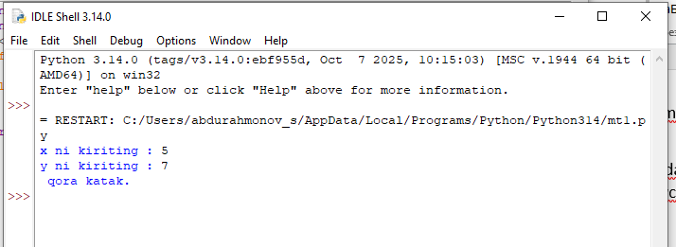

2.
n = int(input("n ni kiriting: "))
if n > 0:
S = 0
for i in range(n, 2 * n + 1):
S += i ** 2
print(S)
else:
print("n musbat butun son bo‘lishi kerak!")
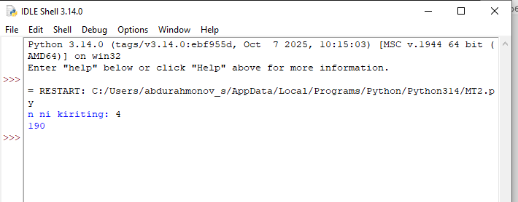
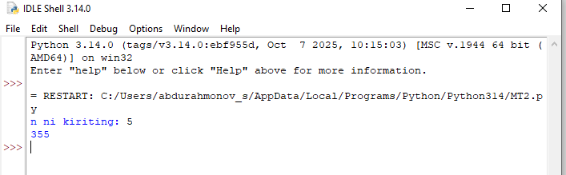
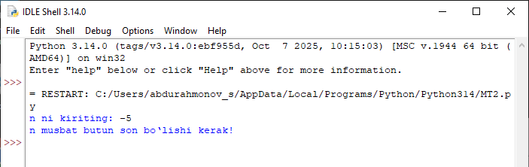
3.
binary_str = input("Ikkilik sonni kiriting: ")
if all(ch in '01' for ch in binary_str) and len(binary_str) > 0:
decimal_value = int(binary_str, 2)
print(f"O‘nlik sanoq sistemasidagi qiymat: {decimal_value}")
else:
print("Xatolik: faqat 0 va 1 lardan iborat ikkilik son kiriting!")
